**Lesson 02 Demo 01**

**Setting up and Monitoring with Node Exporter**

**Objective:** To set up and monitor Node Exporter, which exposes system metrics from a Linux host, making it a valuable tool for monitoring hosts within a Prometheus ecosystem

**Tools required:** Linux operating system

**Prerequisites:** None

Steps to be followed:

1. Download and set up Node Exporter on localhost
2. Set up a Prometheus server on localhost to scrape Node Exporter metrics
3. Access Node Exporter metrics using Prometheus UI

**Step 1: Download and set up Node Exporter on localhost**

1. Navigate to the terminal on the Ubuntu system and execute the following command to download Node Exporter:

**sudo wget https://github.com/prometheus/node_exporter/releases/download/v1.8.2/node_exporter-1.8.2.linux-arm64.tar.gz   
  
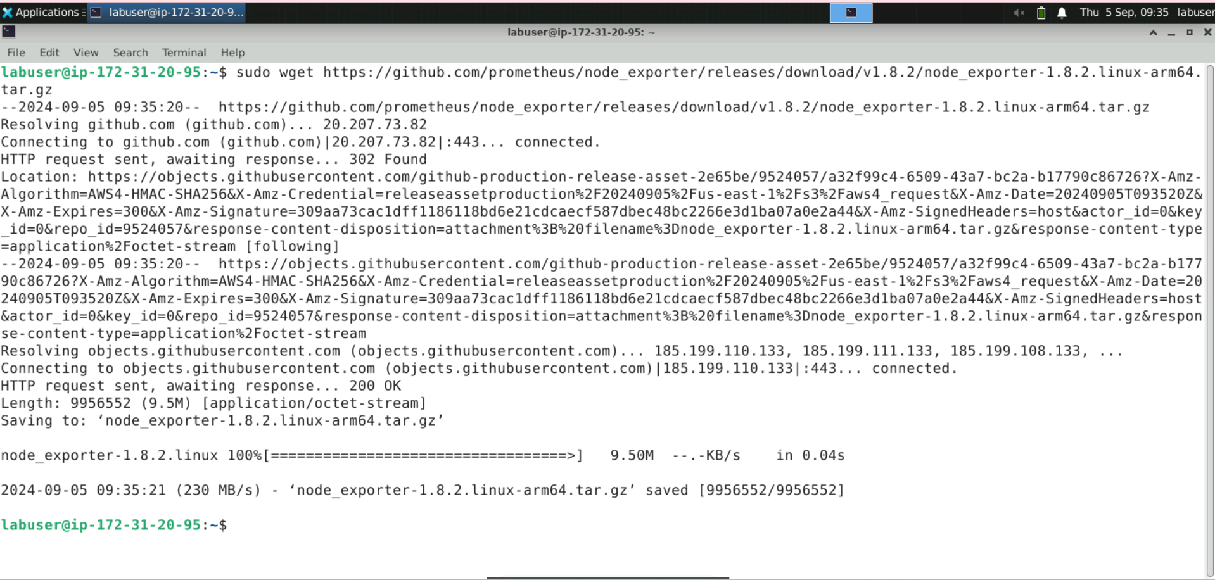**

1. Run the following command to extract the downloaded Node Exporter package:

**sudo tar xvfz node_exporter-*.*-arm64.tar.gz**

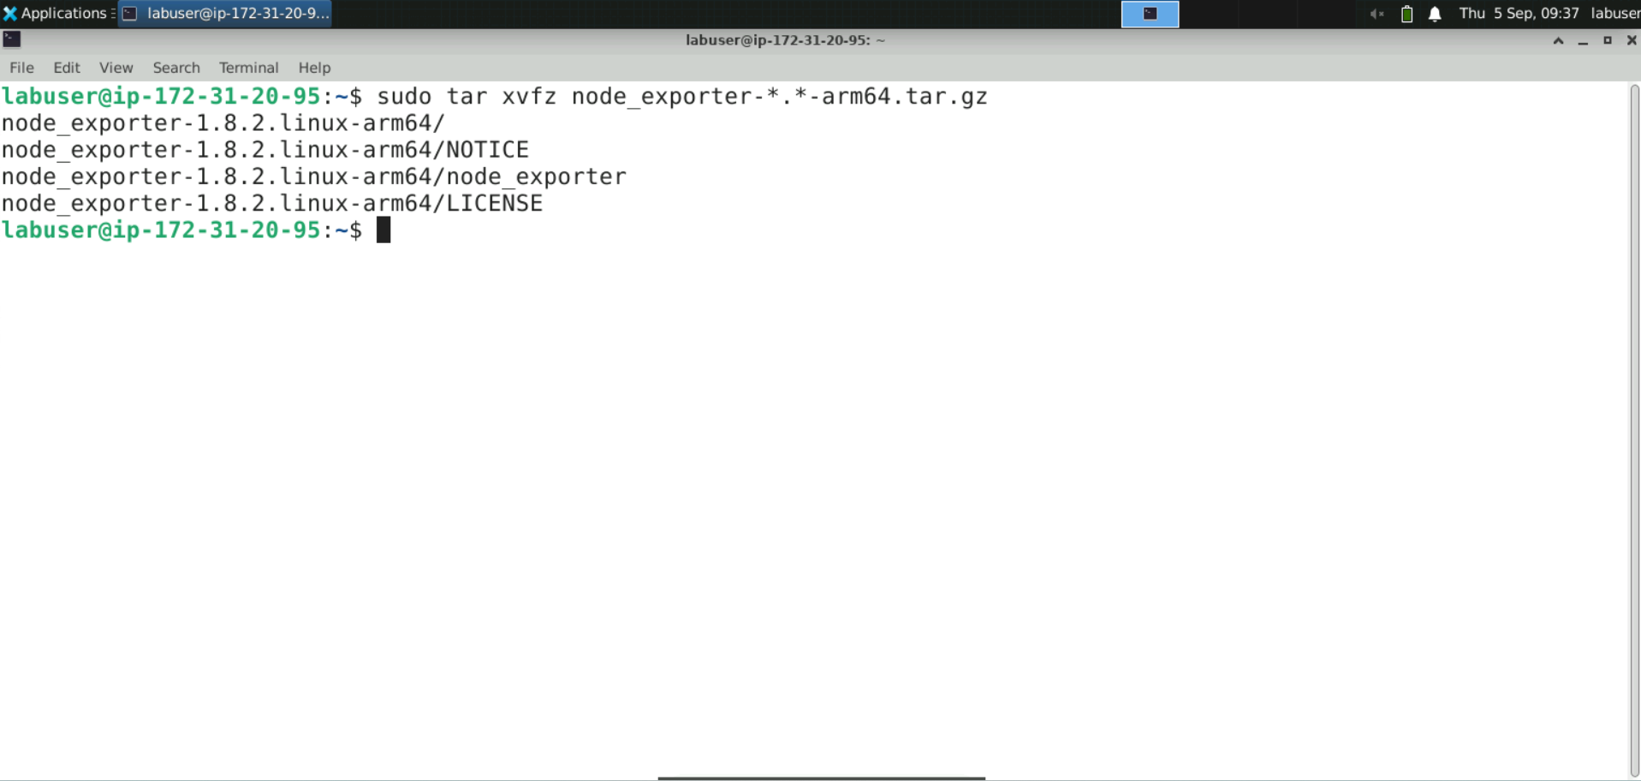

1. Delete the downloaded **.tar.gz** file to free up space, then create a new directory named **Node_Exporter** and move the extracted Node Exporter files into the newly created directory using the following commands:

**sudo rm node_exporter-1.8.2.linux-arm64.tar.gz**

**sudo mkdir node_exporter**

**sudo mv node_exporter-*.linux-arm64/* ./node_exporter**

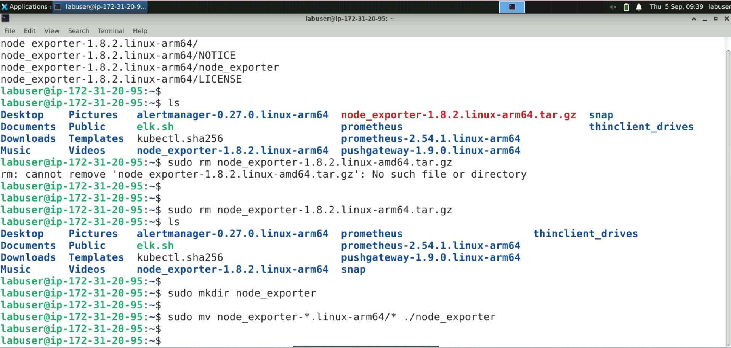

1. Execute the following commands to change the directory and start the node_exporter in the background, redirecting output to **/dev/null**:

**cd node_exporter**

**sudo ./node_exporter > /dev/null 2>&1 &**

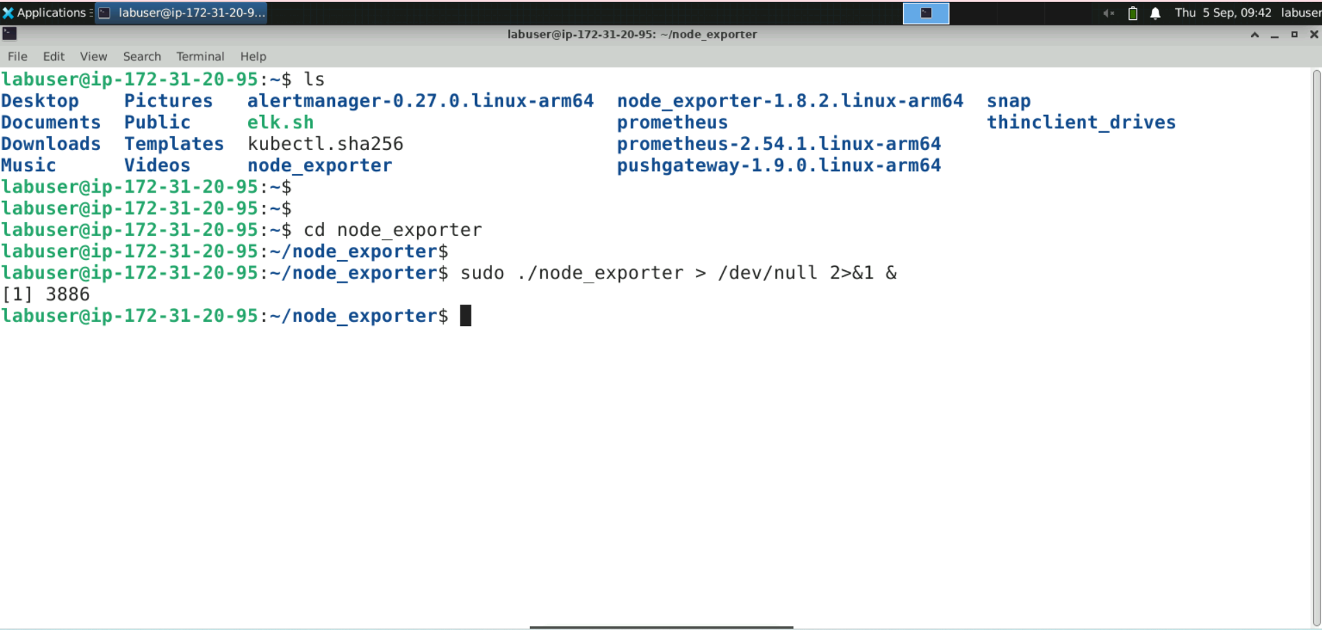

1. Verify that Node Exporter is running by fetching its metrics with the following command:  
   **curl http://localhost:9100/metrics**

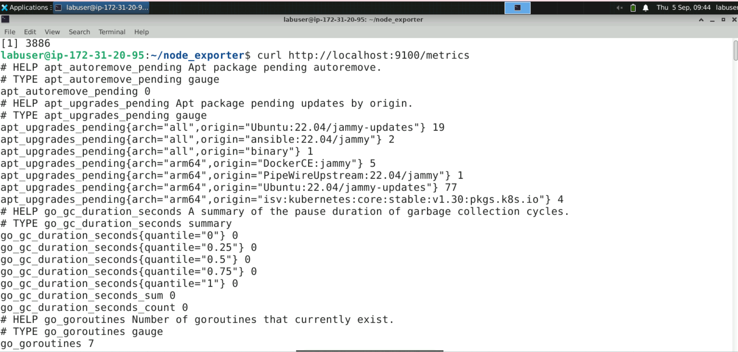  
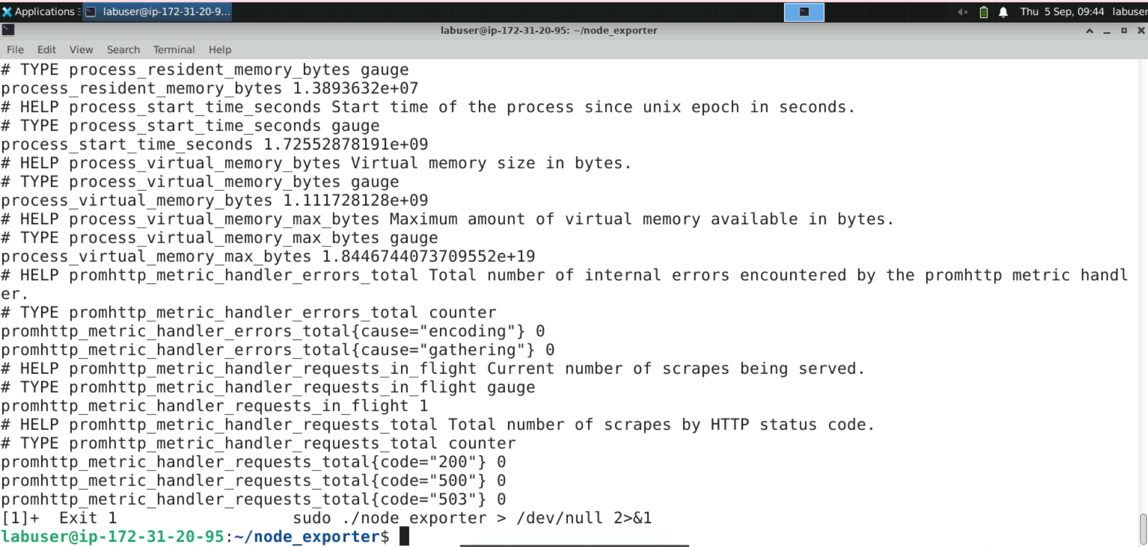

**Step 2: Set up a Prometheus server on localhost to scrape Node   
 Exporter metrics**

1. Change the current directory into the **prometheus** directory, then open the **prom-node-exporter.yaml** file in the **Vim** editor for editing using the following commands:   
   **cd ..**

**cd prometheus**

**sudo vim prom-node-exporter.yaml**

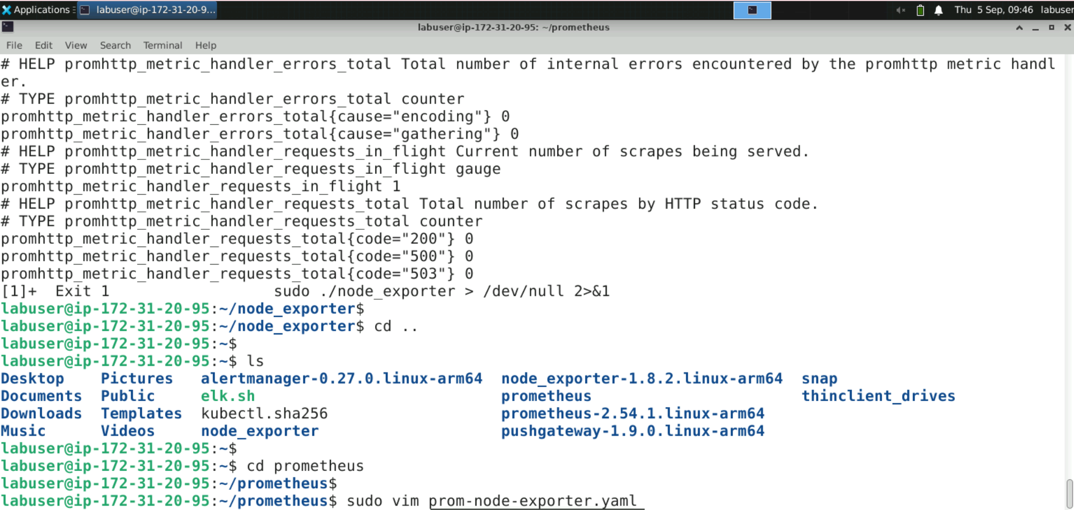

**Note:** Other editors like **vi**, **nano**, and more can also be used instead of **Vim**.

The **Vim** editor appears as shown below:

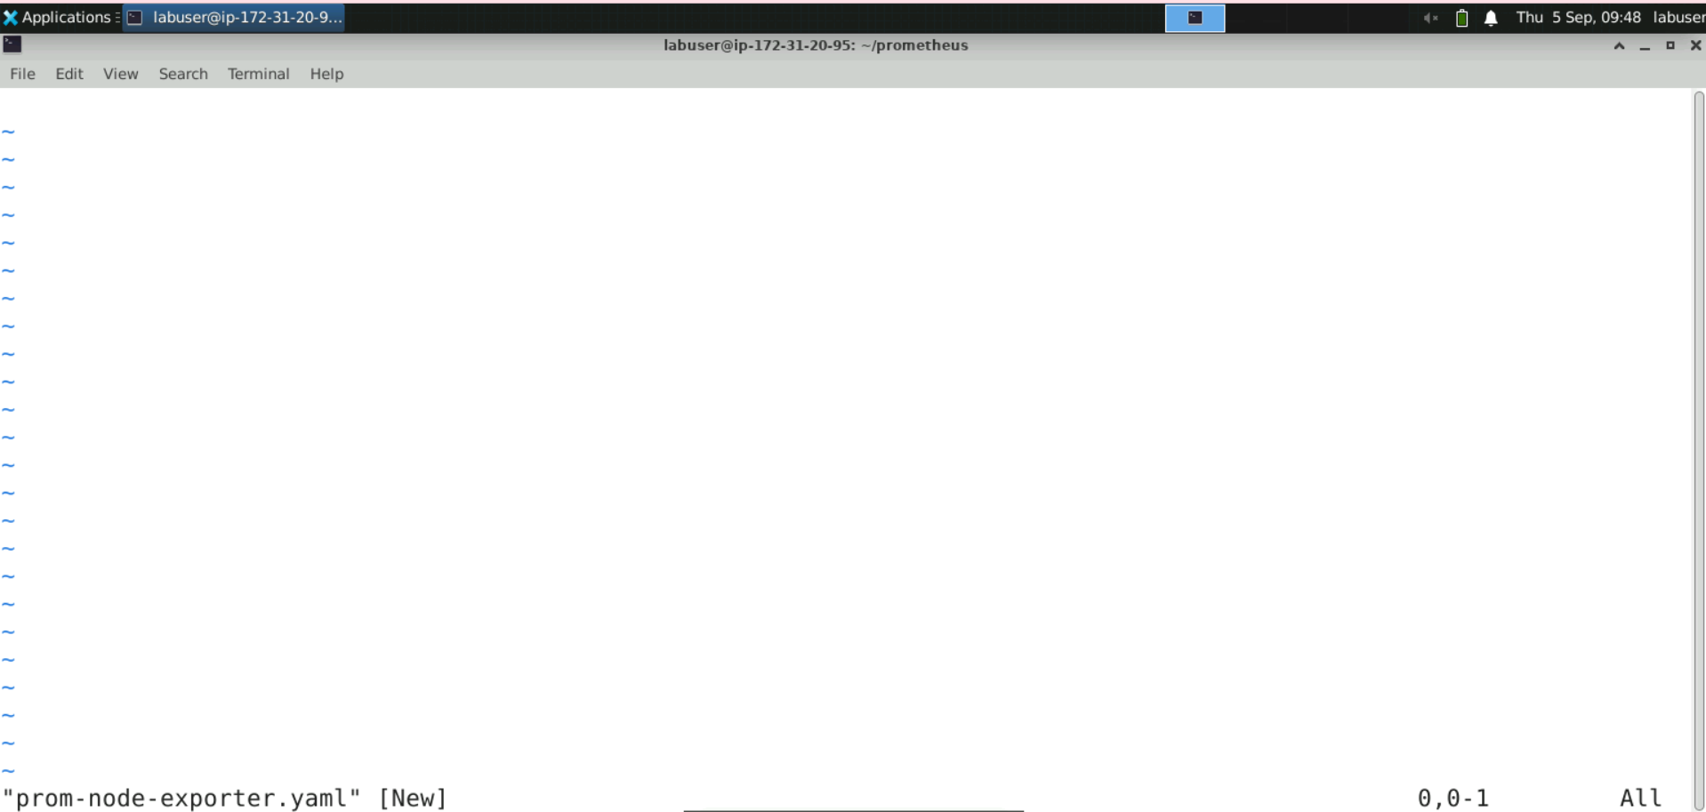

1. Press **I** to switchto **INSERT** mode, then copy the following YAML configuration into the file:

**global:**

**scrape_interval: 15s**

**scrape_configs:**

**- job_name: node_exporter**

**static_configs:**

**- targets:**

**- localhost:9100**

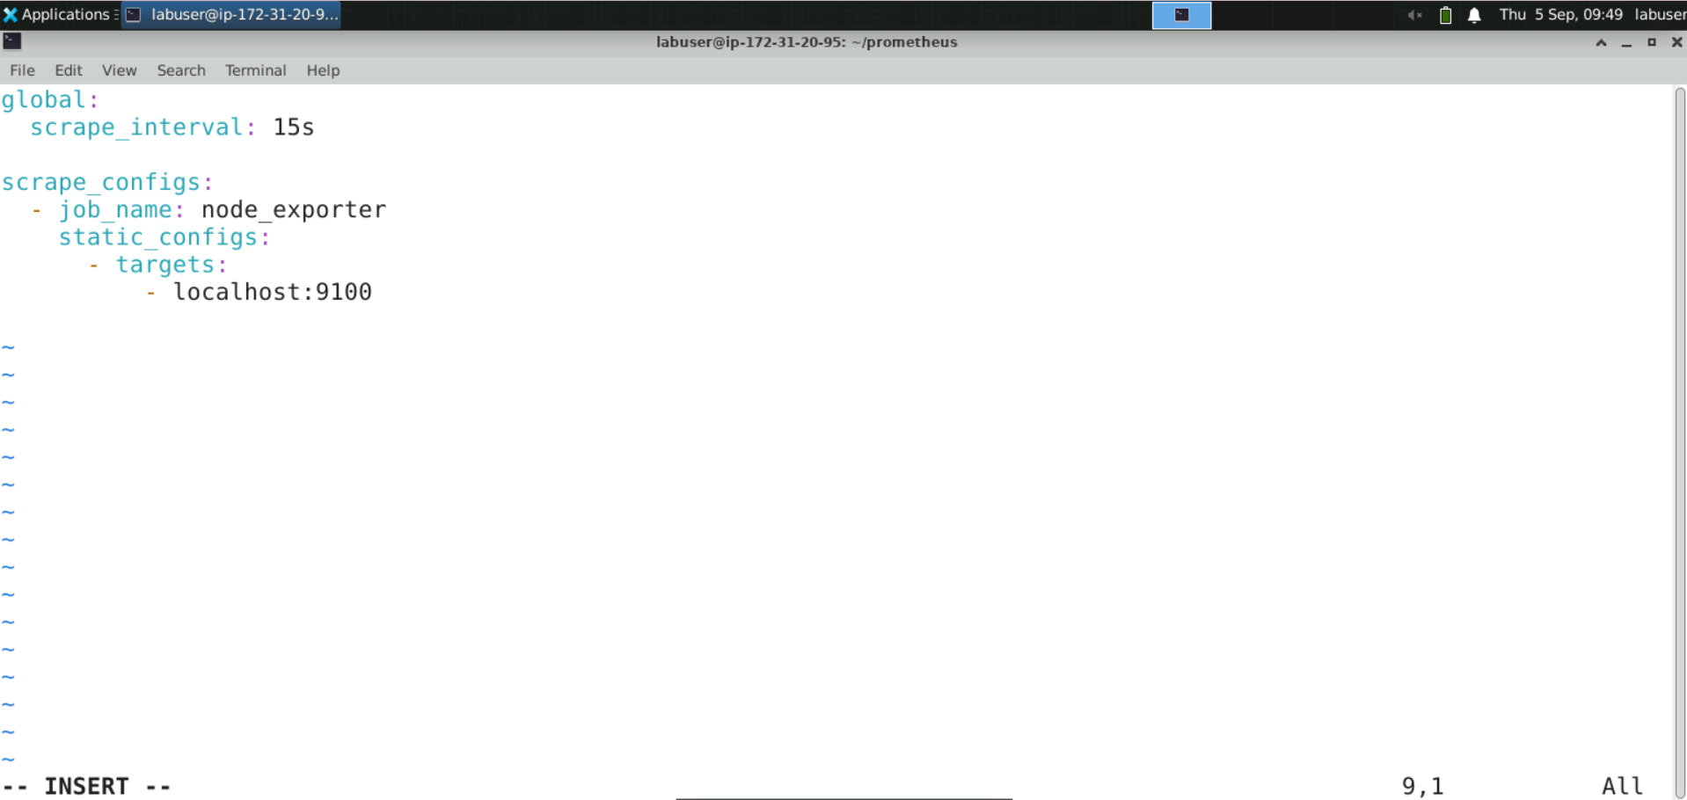

1. Type **:wq** to save and exit the file

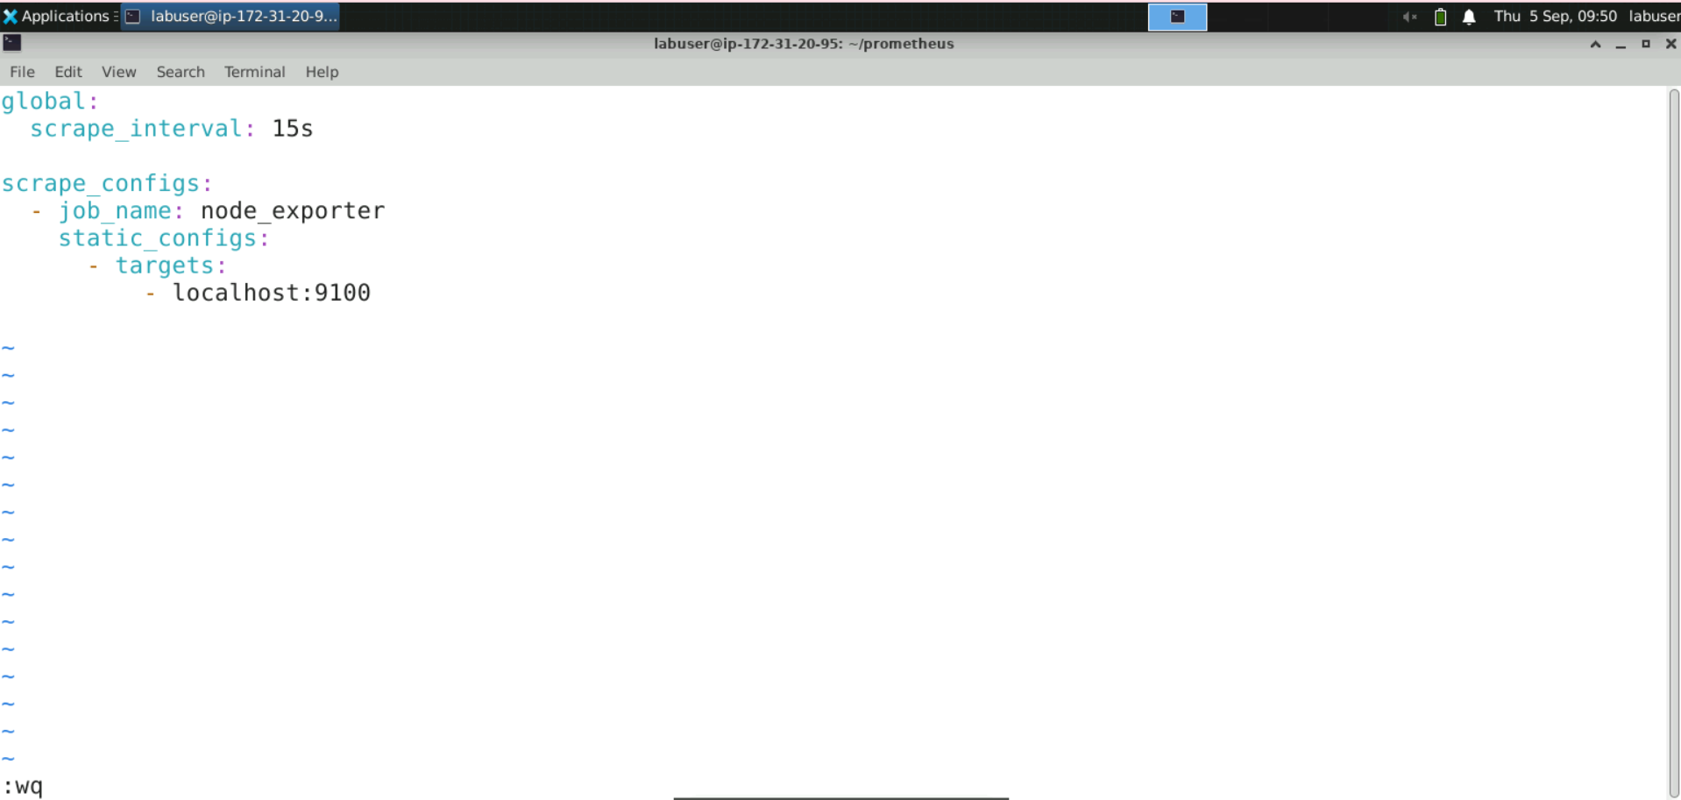

1. Execute the following command to start the Prometheus server using the configuration file to monitor Node Exporter:  
   **sudo ./prometheus --config.file=prom-node-exporter.yaml**

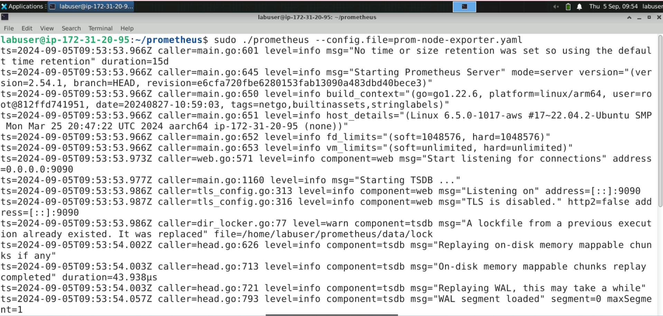

**Note:** If you encounter any port conflicts, run the following commands to resolve them:

Find which process is occupying the 9090 port: **sudo lsof -i :9090**

Stop that process: **sudo systemctl stop <process_name>**

**Step 3: Access Node Exporter metrics using Prometheus UI**

1. Navigate to the browser and enter the URL **http://localhost:9090/** or **http://<public-ip>:9090/** to access the Prometheus console

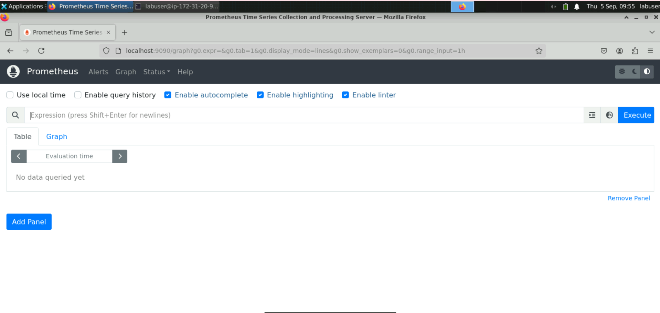

1. Click on **Graph** and use the expression browser to plot the **node_cpu_seconds_total** metric, then click on **Execute**

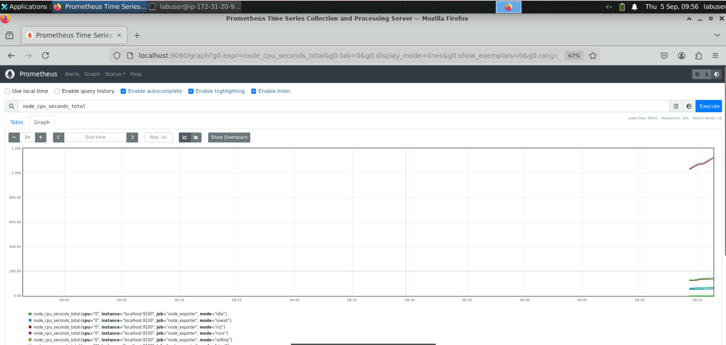

1. Visualize the graph using the **node_memory_Active_bytes** metric

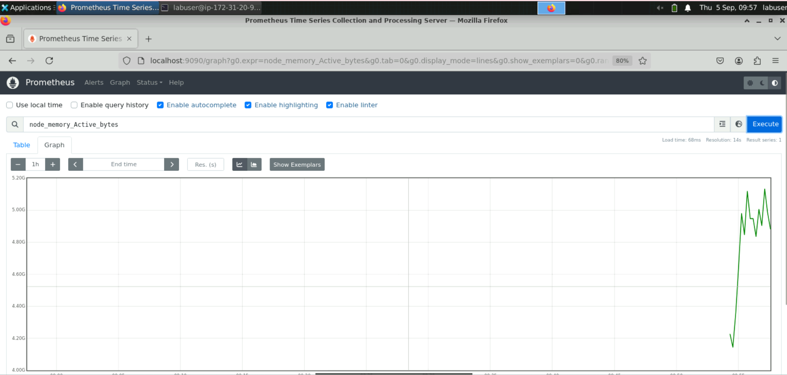

1. Select **Targets** under the **Status** section to view the health of the scraped **node_exporter** target

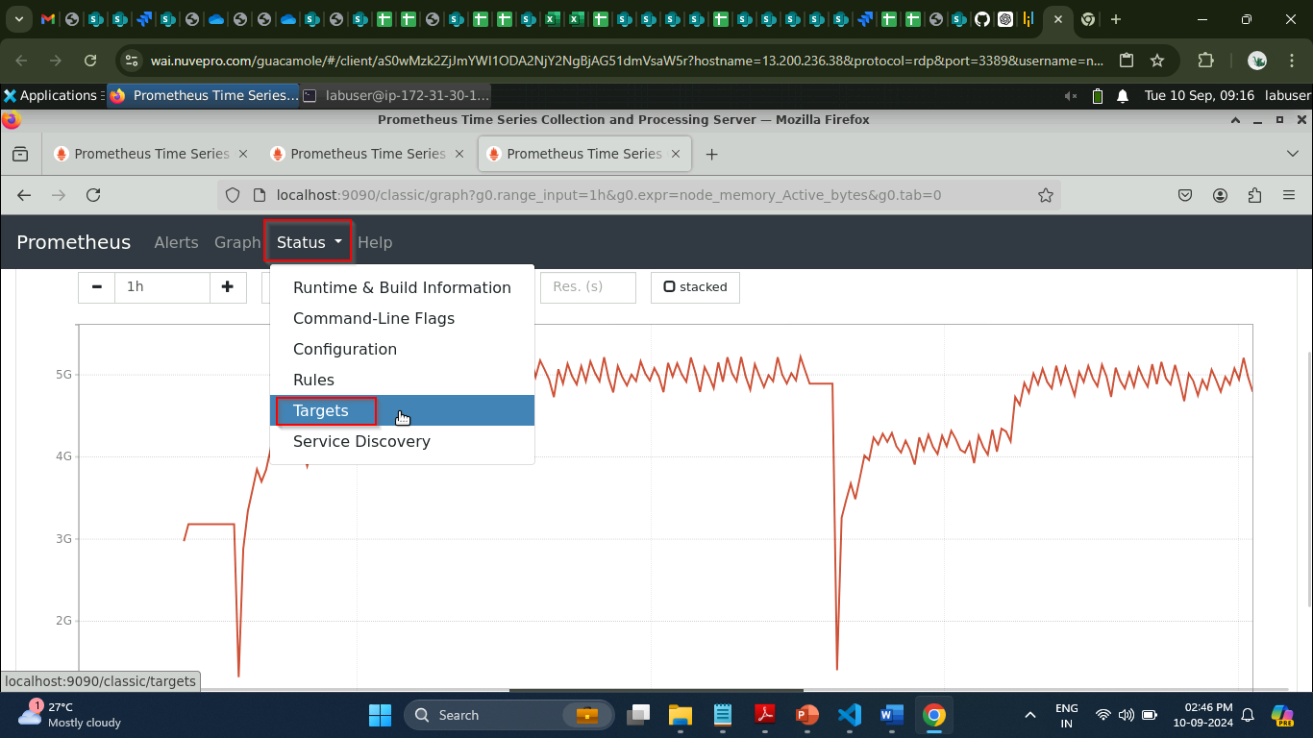

By following these steps, you have successfully set up and monitored system metrics from a Linux host using Node Exporter, integrating it effectively within the Prometheus ecosystem.